|  |  |  |  |  |  |
| --- | --- | --- | --- | --- | --- |
| Date | 6-Dec-22 | | | Tester Name | Richard Belanger |
| Environment | Penfax - Test | | | Login used | TEST2 |
| Operating System | Windows | Version: | Update: | | |
| Software Used | Edge | Version: | Update: | | |
| Not Applicable | Version: | Update: | | |
| Release version | 22.4.1 | | | | |
| Title | M13.02 Death of Deferred married member eligible to retire | | | | |
| Test Type | Regression | | | | |
| Test Scenario | Member terminated due to death benefit calc’d for spouse | | | | |
|  |  | | | | |
| Expected Results | Calculated Deferred member’s death benefits for Spouse will be correct | | | | |
| Pass/Fail | Pass | | | JIRA# | N/A |

Describe your steps with screenshots:

Deferred Married Member eligible for pension> Member terminated due to death

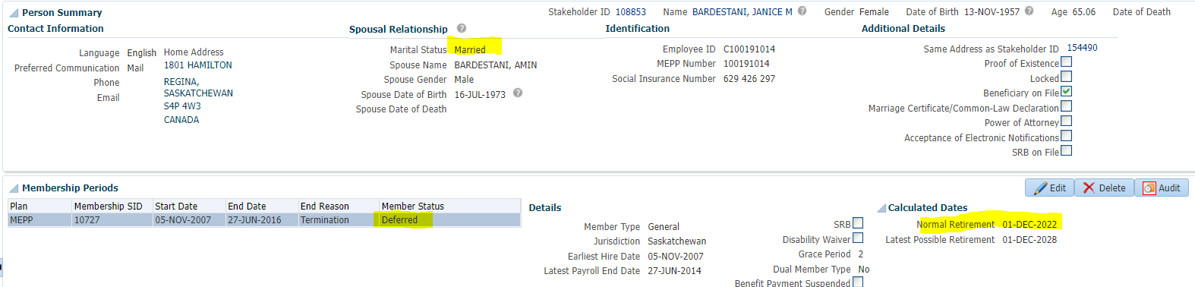

Member terminated due to death

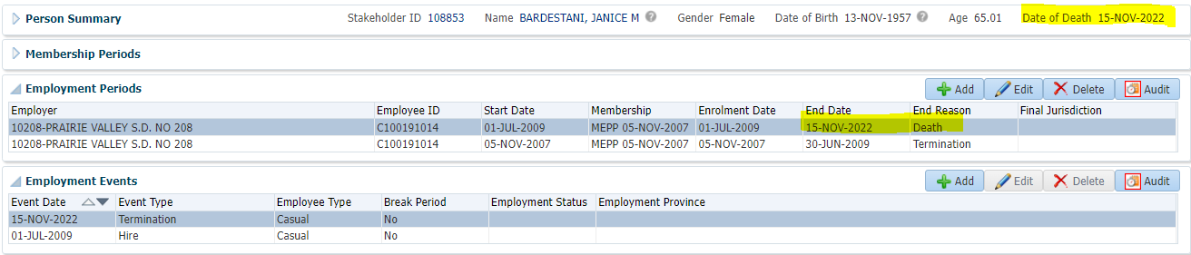

To Benefit Calculation>Calculate

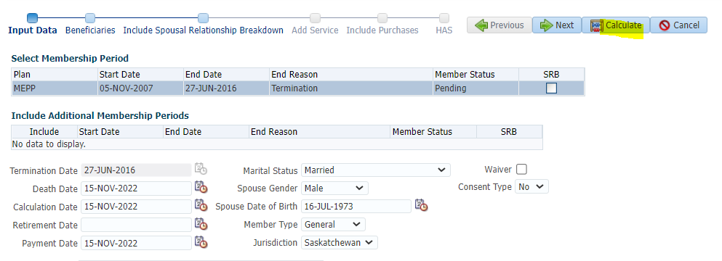

Processed

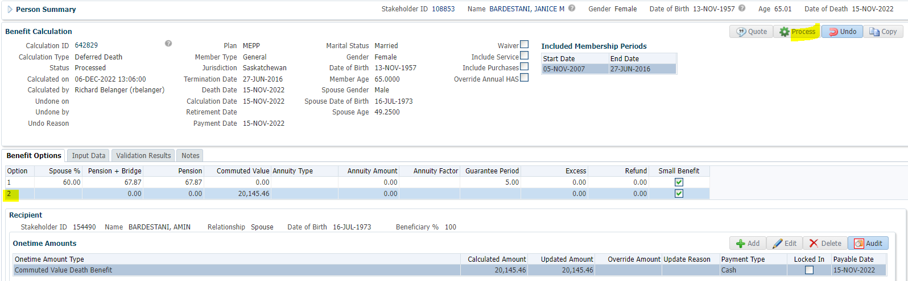

To Benefit Selection>Next

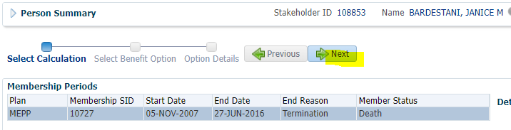

Choose Option add payment date>Next

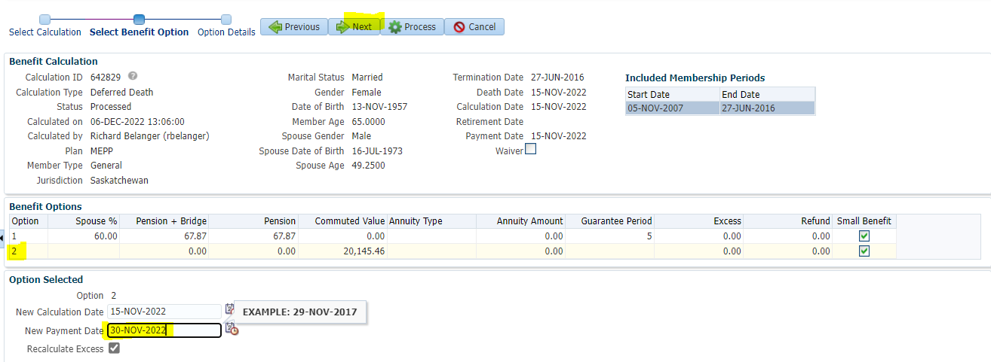

Add Payment Instructions>Process

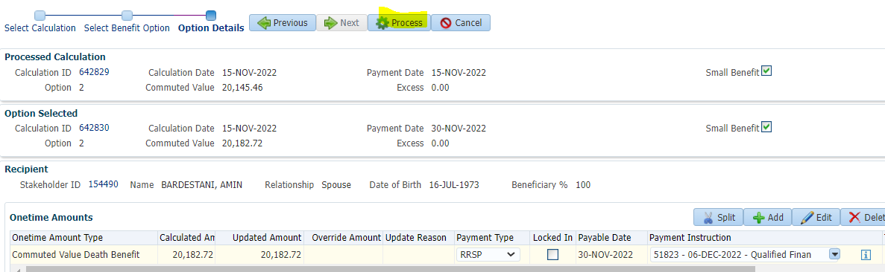

Processed>To Spouse>Benefit Recipient>Submit for Approval and Approve the Payment line

To Summary>Authorize

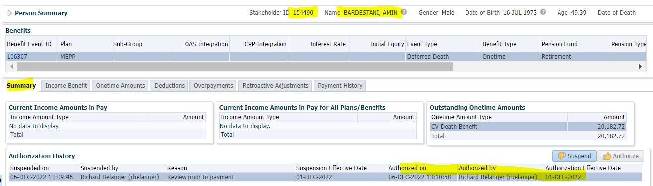

Payment Batch to run to see payments made>Member received RRSP so no Tax will be taken

